 



Medicine Reminder and Monitoring System for Secure Health Using IOT

*a*

**Abstract**

In modern society, busy life has made people forget many things in day to day life. The elderly people and the people victims of chronicle diseases who need to take the medicines timely without missing are suffering from dementia, which is forgetting things in their daily routine. Considering this situation study has been done in this. Paper reviewing the technologies of home health care which are currently used for improving this situation by reminding the scheduled of medicine, remote monitoring and update new medicine data of patients, which can be done by prescriber through web.

© 2016 The Authors. Published by Elsevier B.V. This is an open access article under the CC BY-NC-ND license ([http://creativecommons.org/licenses/by-nc-nd/4.0/).](http://creativecommons.org/licenses/by-nc-nd/4.0/))

© 2016 The Authors Published by Elsevier B.V.

Peer-review under responsibility of organizing committee of the International Conference on Information Security and Privacy (ICISP 2015)

Peer-review under responsibility of organizing committee of the ICISP2015

1. **Introduction**

Most of the time due to number of work for the people as well as regarding age and some disease which leads to forget the basic things among daily routine.

If the patient sufferings from the disease where it is compulsory to take medicine at proper time, in this paper we have review the technology of home health care system among them a medicine reminder system and some improvement regarding authentication have well focused.

Generally for home based health care the arrangement include communications, imaging, sensing and human computer interaction technologies embattled at diagnosis, treatment and monitoring patients without disturbing the quality of lifestyle. It can be possible the development of a low cost medical sensing, communication and analytics device that is real-time monitoring internet allowed patients physical conditions. Internet of Things (IoT) network will provide active and real-time appointment of patient, hospitals, caretaker and doctors apart from this the secured data transmission from source point to destination for the purpose of remote monitoring there is need of the architecture of a low cost embedded platform for Web-based monitoring 1.

The distant monitoring is made possible by using various biomedical devices, they measure and transmit data via Bluetooth or ZigBee to a unit that manages them (PC, iTV). The collected information may be stored on the device or sent to a collection centre that provides a complete monitoring, for both health professionals and patients. Access to the medical centre can be allowed, via web, from mobile device or PC 2

The IOT and RFID combination also play a vital role in object detection and personal identification which can be use categorized the person while remote monitoring when number of people information have observed which will helpful to unique identity to each patient and their respective data will be stored .

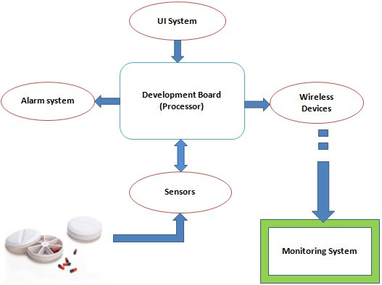

Fig. 1. Showing the block diagram of medicine reminder including remote monitoring.

As a Consequence of healthcare reforms, digital medical records have facilitated the widespread availability of publicly available, statistical data. Feeding the pool of mounting data is the patient doctor interaction Physicians assess the patient’s complaint and prescribe a course of action2

The data collected provides the basis for a decision support tool for Patients to compare Prescription Drug Plans based on a patient’s individual situation and preferences. The tool will provide explicit information that will assist the patient in determining the most suitable prescription drug plan, taking into account the individual importance of plan features. Utilizing historic data, comparisons on Prescription spending will be made to past patients who have a similar health profile as identified by the current patient3.

Figure 1, is observed result from review which leads to home health care module specifically for the medicine whose technology discuss in technique requirement part. In overall system function the alarm will generate according to scheduled and the situation can be recorded with help of sensor which will remotely monitor, save for the future reference, update drug information according to need through web after comparing drug taking habit of patient.

473

# Literature Review

Ilkko et al4 proposed UbiPILL A Medicine Dose Controller of Ubiquitous Home Environment (2009), Home automation and wireless sensor network which have enhancing the quality of life by providing security, information and comfort. Here had discuss a centric home server with three main roles: use of existing Interfaces on registered systems for remote monitoring and Control, serving the surrounding system as a data gateway and Providing content adaptive user interfaces enhanced by Belongings of end-user client devices, the ubipill device had implemented to remind people for elder and for monitoring purposes ubipill and home server have been design to reliably monitor the medicine box activity by web browser.

Kliem et al5 proposed Security and communication architecture for networked medical devices in mobility- aware eHealth environments (2012), Telemedicine concept is cost efficient and location autonomous monitoring system, the suitable and secured medical data can be transferred with different devices with attention towards security and privacy issue. Emergency situations need on the flutter network integration and data transmission fluctuating from domains like patients home, medical practices, ambulances and, hospitals, where each domain may parallel to a different authority so, mobility aware approach allowing out of the box medical device integration and authentication, and simultaneously fulfilling the typical security and privacy requirements of e-health environments.

Parida et al3 proposed Application of RFID Technology for In-House Drug Management System (2012), RFID based technology have used to make drug management system, in this tracking of medicine can be done including emergency or regular medicine with or without RFID tag .the HF tag have assigning the user and by employing RFID reader along with camera and web based system to track the user. This system can be beneficial for the old age, less educated people.

Clifton et al2 A Self-powering Wireless Environment Monitoring System Using Soil Energy, proposed A large- scale clinical validation of an integrated monitoring system in the emergency department(2013),In the integrated patient monitoring which include electronic patient data which generally have more amount challenges to acquire cope with artefact data with the help of algorithm, analyzing and communicating the resultant data for reporting to clinician, here in this demonstrated the machine learning technology embedded within healthcare information system which provide clinical benefits for improving patient outcomes in busy environments.

Hamida et al6 proposed towards efficient and secure in-home wearable insomnia monitoring and diagnosis system (2013), Due to the evolution in technology it is now possible to specific timing monitoring here delivers an experimental estimation of communication and security protocols that can be used in in-home sleep monitoring and health care and highlights the most proper protocol in terms of security and overhead. Design Procedures are then derived for the distribution of effective in-home patients monitoring systems

Ray et al7 proposed Home Health Hub Internet of Things (H3IoT)( 2014) , Health is vital part of life and it is quite necessary to give priority health related issue in which digitization helpful by using number of devices through the concept of IOT but due to heterogeneity and interoperability the concept of digitization for health care is neglected, here in this the best focus given to architecture framework for human health hub which have envision of usage of real life implementation.

Shivakumar et al8 proposed Design of vital sign monitor based on wireless sensor networks and telemedicine technology(2014), Vital sign monitor can be implemented with Bluetooth technology which is embedded with sensor, the transmitter will include the application oriented smart phone enable with 3G or IEEE 802.11 i.e. wi fi based transmission. The data from transmitter will be sending to cloud for centralized monitoring takes place; the expert in remote place can view all patient data and in case of emergency can take appropriate action.

Ajmal Sawand et al1 proposed Multidisciplinary approaches to achieving efficient and trustworthy eHealth monitoring systems(2014),The technological merging between IOT, wireless body area network and cloud computing have vital contribution in e health care which improve the quality of medical care, basically patient centric monitoring play a role in e health care services which involve medical data collection, aggregation, data transmission and data analysis here entire monitoring lifecycle and essential services component have discus as well as design challenges in designing the quality and patient centric monitoring scheme along with potential solution.

Huang et al8 proposed the intelligent pill box—Design and implementation (2014), the implementation of pill box has proposed by keeping the problems of old age people in mind to provide full medication safety. The pill box will remind the patient about timing by doing this drug abusing can be controlled.

Al-Majeed et al10 proposed Home telehealth by Internet of Things (IoT) (2015), The real time monitoring can be possible through IOT which helps in development of low cost medical sensing, communication and analytic devices

474

which make quality of life, in case of density of messages there is fear of information degradation but by using proper algorithm we can resolve the problem and can make the low cost imaging, sensing and human computer interaction technology.

Lin et al9 proposed A Self-powering Wireless Environment Monitoring System Using Soil Energy (2015), The monitoring system can uses the self-powering wireless environment with the help of renewable energy which can be beneficial in remote places where the power problem in wide manner, in this the system have demonstrated which will uses soil energy with carbon, zink electrodes.

Moga et al11 proposed Embedded platform for Web-based monitoring and control of a smart home (2015), Present the low cost embedded platform for web based monitoring and controlling and the platform consist of distributed sensing and control network and touch screen to easy use interface to the user and remote web based access.

Table 1. Analysis of technologies for monitoring system based on review papers Author Technology Describe

* 1. Leo Ilkko UbiHOMESERVER
  2. Andreas Kliem Bluetooth (phone), encryption key used in authentication
  3. Malabika Parida RFID technology
  4. Fu-To Lin A self-powering wireless
  5. S. Tmar BenHamida HTTP, MQTP protocol
  6. Partha P. Ray IOT
  7. Nair Siddharth Shivakumar A wireless sensor network and telemedicine technology
  8. Ajmal Sawand IOT, Wireless Body Area Networks
  9. Shih-Chang Huang Arduino, Skype, Infrared sensors
  10. Dr. Salah S. Al-Majeed Telemedicine technology, IOT, Cloud
  11. Daniel Moga Web of things

# Useful Technique for Medicine Reminder and Monitoring System

After observing all the literature, the following technologies are identified which can prove beneficial for designing of Medicine Reminder and Monitoring System for Secure Health Using IOT.

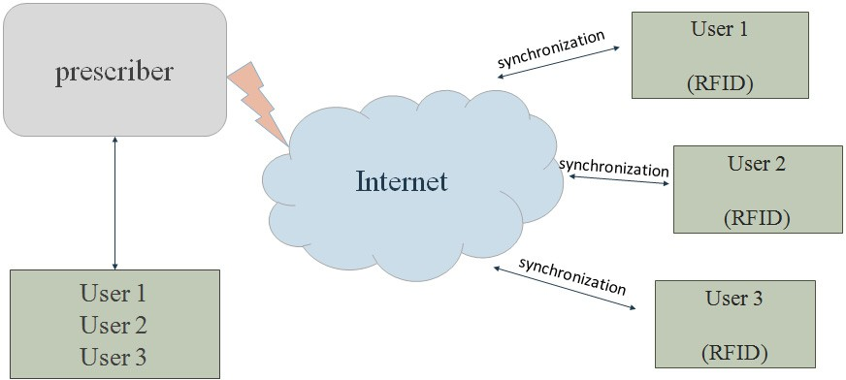

Fig. 2. Showing the mode of communication and authentication technique.

* UI: To make changes if any in system.

475

* Intelligent control: Control system comprising sensors for monitoring and reporting the state of the environment and its associated control software, which regularly check the medicine taken by patient or not .
* IoT:( Internet of Things) has evolved from the convergence of wireless technologies, micro- electromechanical systems (MEMS) and the Internet. The concept may also be referred to as the Internet of Everything. to exchange data of things or physical object, this is embedded with electronics, related software, sensors and network connectivity. Which allow to sensed and collect data remotely, it generate opportunity to direct integration between physical world and computer based system have economic, accuracy and efficiency benefits.
* The use of open standard like ISO/IEEE 11073-20601 group of standards addressing the interoperability of personal health devices12
* MQTT messaging protocol will best suited due to less memory, processor and bandwidth13
* The use of open source IOT cloud will be effective.
* RFID and RFID reader: RFID is utilized to give unique identification to user so that while remote monitoring the prescriber can distinguish the patient on same page14
* Web page: web page will be used for remote monitoring of medicine scheduled fallowed by patient and to upload the changes if any found after comparing the variation in medicine consuming activity in scheduling, quantity, timing of drug.
* Alarm System: The alarm system is used to give the indication of medicine through voice message.
* Appointment from home: The provision will be on the box which will take patient appointment of the doctor here, RFID will be the Identity of patient.
* Benefit of using RFID tag: Used for Encryption/Decryption Technology15

1. **Working Flow Chart**



Start

Get scheduled of medicine

Is correct time ?

No

Database

Yes

Is taken?

Notify

No

Yes

Wait

Fig.3.Working Flow Chart of Medicine Reminder.

The conceptual working of medicine reminder and monitoring system in flow chart describes the scheduling and the procedure of taking medicine, if schedule is followed by patient or not the data will be stored in the cloud. The stored data will be used to analyze record of patient and further prescription will be give according to it.

1. **Conclusion**

For home health care various technology have evolved as review considered, in this paper medicine, its scheduling have well focused which is beneficial to improve efficiency of prescribed drug and reduce economic factor. To improve the existing home health care technique number of monitoring technology has observed which leads to home health monitoring system. The monitoring system can be implemented with sensing element and wireless module which should need to secure so that message containing the health related information should not be corrupt.

IOT (Internet of Things) play a vital role in communicating the two devices, the use of messaging standard and communication protocol we can securely transfer the important messages regarding to health. open source IOT cloud will be effective for storing sensors data,the benefit of digitally storing is the retrieving of data is easy and faster manner in case of emergency for secure health. For the user personal identity and Encryption/Decryption purposes the RFID will best.